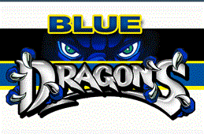

**Chemistry Bev Howe**

**Week 36 May 8 – May 12**

|  |  |  |  |
| --- | --- | --- | --- |
|  | **Monday** | **Tuesday** | | | **Wednesday** | **Thursday** | **Friday** |  |  |
| **Objective(S)**  (wHAT DO i WANT sTUDENTS TO knOW/) | To identify the different kinds of chemical reactions and balance equations | To check student understanding of chemical equations and identifying the different types of equations | | | To determine the pH of common household liquids. | To determine the pH of common household liquids. | To review notes and problems from the second semester. |  |  |
| **InTRUCTIONAL mETHODS**  (hOW AM i GOING TO inSTRUCT/) | Review over balancing equations and identifying the different kinds of reactions. | Answer questions before test | | | Introduction of lab activity using red cabbage indicator to determine pH. | Continue with lab activity using pH. | Answer questions over semester review packet |  |  |
| **AsSESSMENT**  How will I assess Learning | Quiz chemical reaction types and balancing equations. | Chapter 11 Test  Balancing Equations | | | pH Activity  Lab report | Lab report and real life applications due at end of period. | Semester Review |  |  |
| **CLOSURE** | Chapter 11 Test on Tuesday |  | | | Real life applications of pH. |  |  |  |  |